

**Bachelor of Science in Computing**

**Software Engineering**

**Year 2022-23 / Semester 2**

Internal Examiner: Wei Ren

Internal Moderator: Wenhao Fu

External Examiner: Maria Barry

Date: 24/04/2023

Duration: 2 Hours

Time: 10:00-12:00

Exam Weighting: 60%

Exam Delivery: Computer

**Instructions**

1. This paper contains 1 section with 1 question.
2. You must attempt all parts of the question.
3. All questions are marked out of 100.
4. Please write all answers on the script provided.
5. Clearly number all questions.
6. This is an open-book exam.

***Please do not turn over this page until instructed to do so****. The use of programmable or text storing calculators is expressly forbidden. Please note that where a candidate answers more than the required number of questions, the examiner will mark all questions attempted and then select the highest scoring ones.*

**Question 1**

Please answer the question based on the following scenario: You are managing a software development team that has been invited by “Dorset Bank” to develop an operating system for their ATM machines. The ATM machines should allow clients to withdraw money at any time and deposit cash or checks. Additionally, the machines should display the client's account balance. You have 4 weeks to do this project.

1. Select a development method for this project and provide the reason for your choice, (e.g. waterfall development method, agile development method, etc.). The Agile Method would be a good choice for this project because is a project with a short deadline so the agile methodology is flexible and easy to make chances, allowing to meet the client needs.

**[14 marks]**

1. Provide a comprehensive list of the steps involved in the software development process.

Requirements gathering: collect all the information’s with the client before start the developing the project so things way would be clear for both parts what the project should have.

Design: Check with the client what are the needs and start design the project accordingly with the information’s provided

Implementation (coding process): Start coding and implementing the user experience accordingly with the client needs.

Testing: Run test to check if the code works properly

Deployment: check if the project is ready to be lunch and ensure that attend the clients need

Maintenance: The maintenance should be up to date and all the problems should be fixed so this way is possible to avoid any major problems with the client.

**5 marks]**

1. Write a requirement document based on the client's previous requirements, including functional requirements, interface requirements infrastructure requirements.

Functional requirements:

The machine should be able to request the client card to start the operation

The machine should display the accounts option so the client can navigate between the menu.

The machine should request the client pin number before finish any transaction.

The machine should give an option for withdraw and displays the amount available or give an option for the client type the amount.

The machine should display an option for deposit cash or check.

The machine should give an option to print the receipt when the transaction is finish.

The machine should display a log out option and return the client’s card.

The machine should display the home menu when the client is finish.

Interface Requirements:

The user interface should be user friendly.

The interface should be easy and understandable.

The interface should have a clear navigation.

Infrastructure requirements:

The machine should be safe and secure all the data collected.

The machine should have a cloud base database to store all the data.

**[25 marks]**

1. Create a Use Case Diagram.

**[6 marks]**

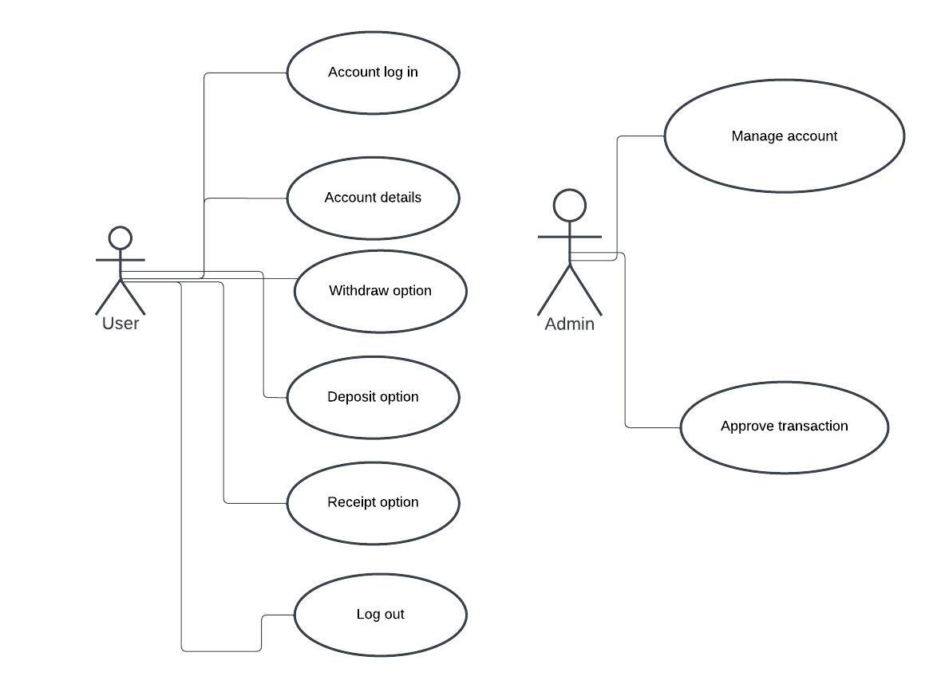

Create a Gantt Chart to manage development process.

Requirements gathering: 5 days

Design: 5 days week

Implementation (coding process): 1 week

Testing: 1 week

Deployment: ongoing

Maintenance: ongoing

**[10 marks]**

1. Provide an example code snippet, in any programming language, that includes the class name, function name, and any other necessary variables, to demonstrate how to achieve the goals of this project. You do not need to include the implementation details of the functions. Please show class diagrams or template code.

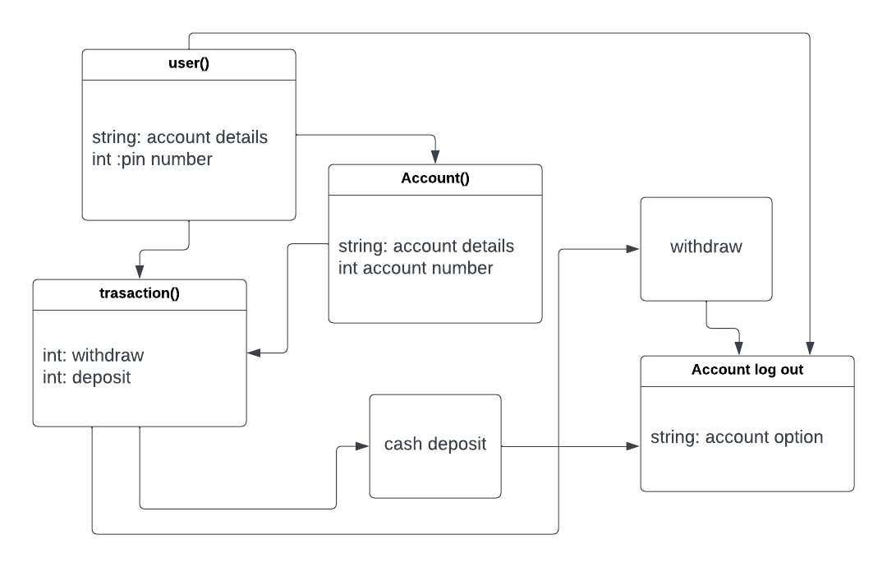

**[20 marks]**

1. Provide a detailed explanation of the validation and verification process that should be followed to ensure the successful completion of this project.

The validation process should ensure that the project meets the clients needs checking the user interface and if the all the information requested are accordingly to the client’s needs. The user interface should be user friendly following the requirements.

Verifications process should ensure that the project is secured and the maintenance are up to date and the project is always update checking all the problems and they are being fixed.

**[15 marks]**

1. Create a repository on GitHub and upload your answers to it. Please note that the answers on GitHub will not be considered for marking, so it is essential to submit all your answers to Moodle before the exam deadline.

**[5 marks]**

**[Total 100 marks]**